Introductory SQL
Exercise01: Complete the SQL and copy the SQL following by screenshots of the output (if the output is too large – only do partial screenshot and mention how many records in total is the output)
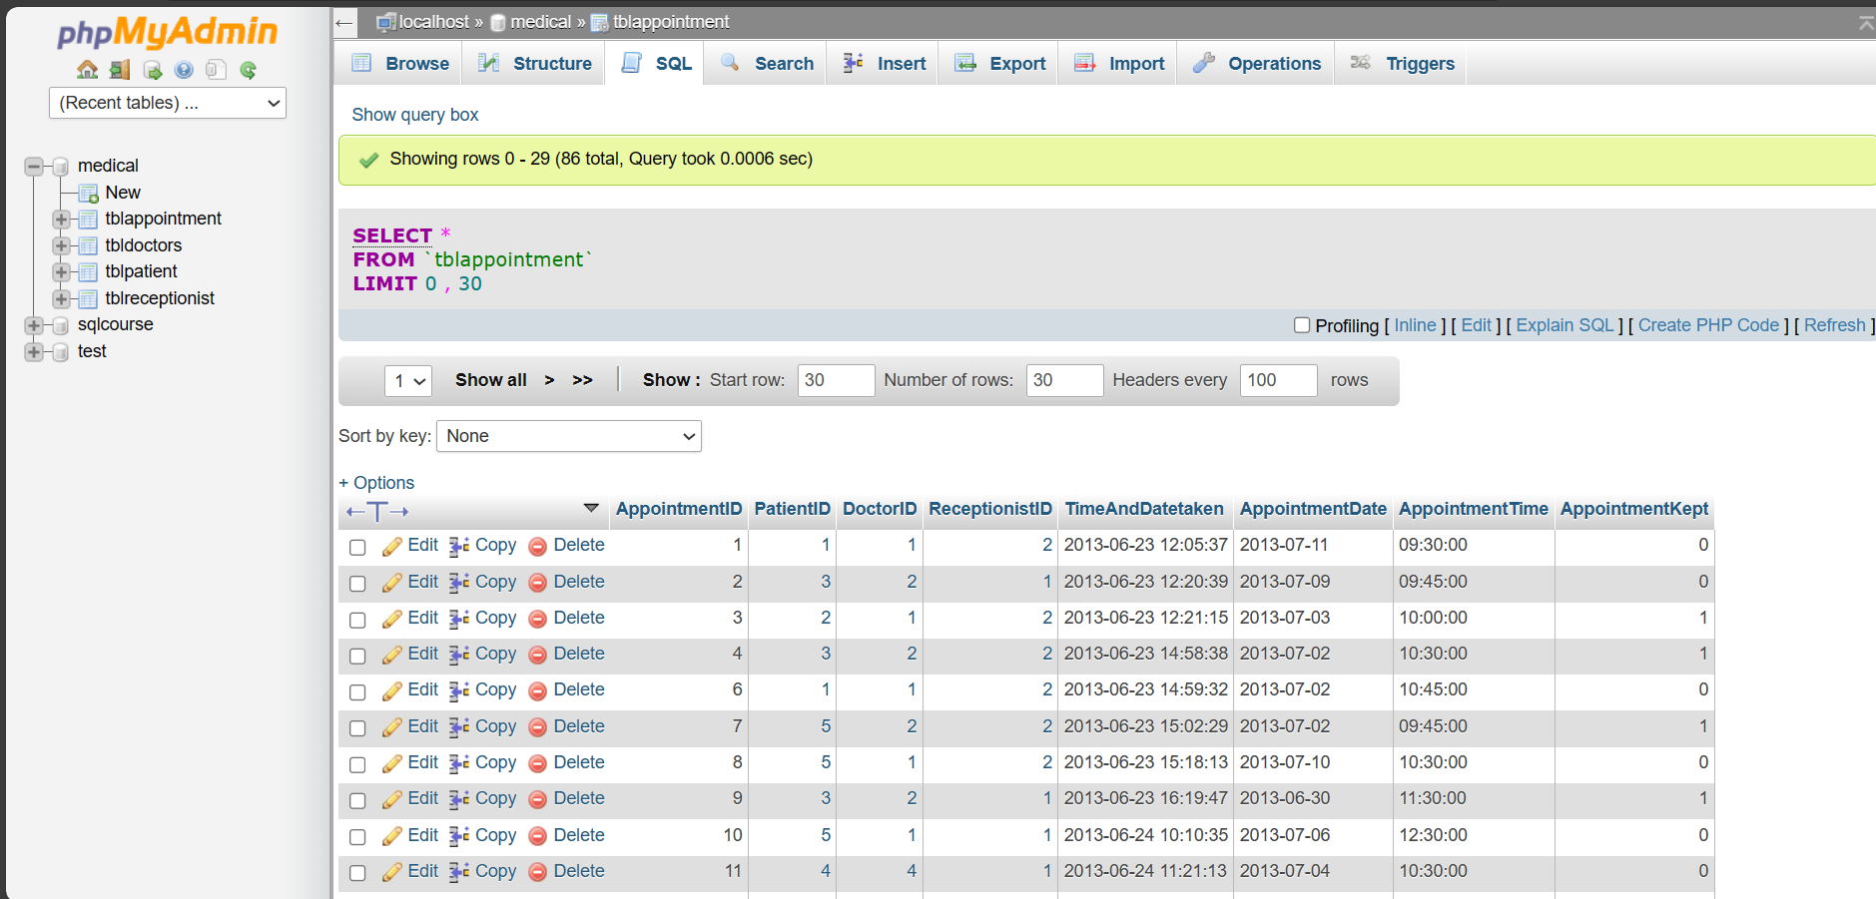
Exercise02: Do the same as the above, this time using the other three tables provided, choose any three attributes and then display these in the output. Show the SQL code and screenshot the output (as usual). Use of the DISTINCT command after the SELECT statement. Applying the DISTINCT command across the primary key doesn’t have any purpose, since all the records would naturally expected to appear. Since the primary key by its very definition is that the values need to be unique. e.g. SELECT DISTINCT PatientID FROM tblpatient; A more purposeful application of DISTINCT would be showing the counties that the patients come from.
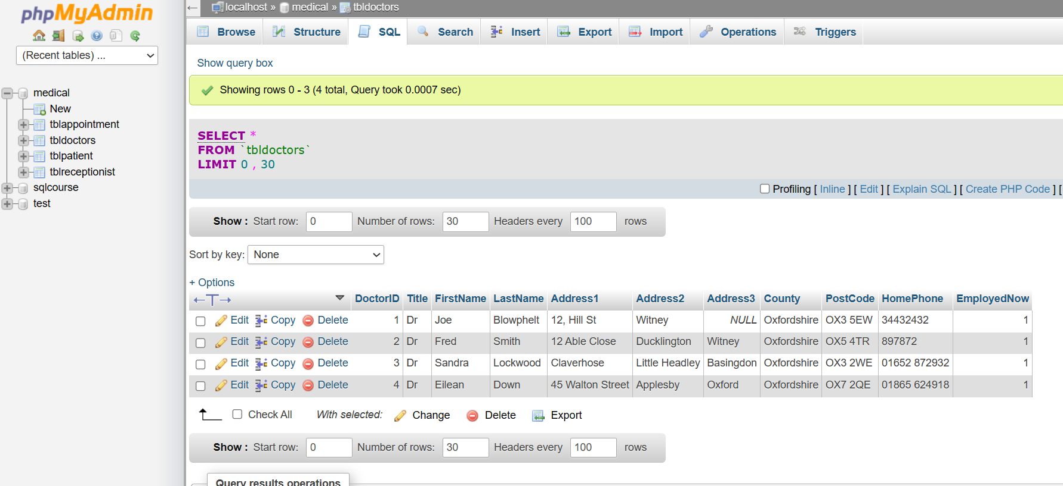
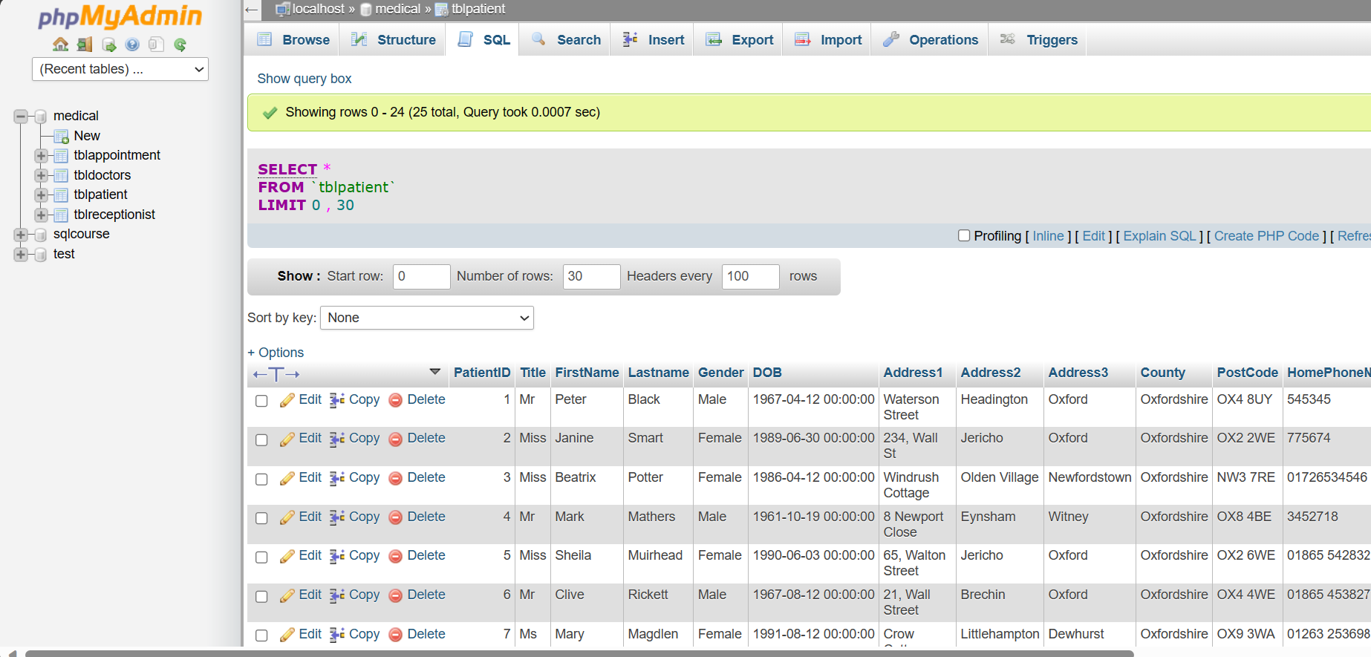

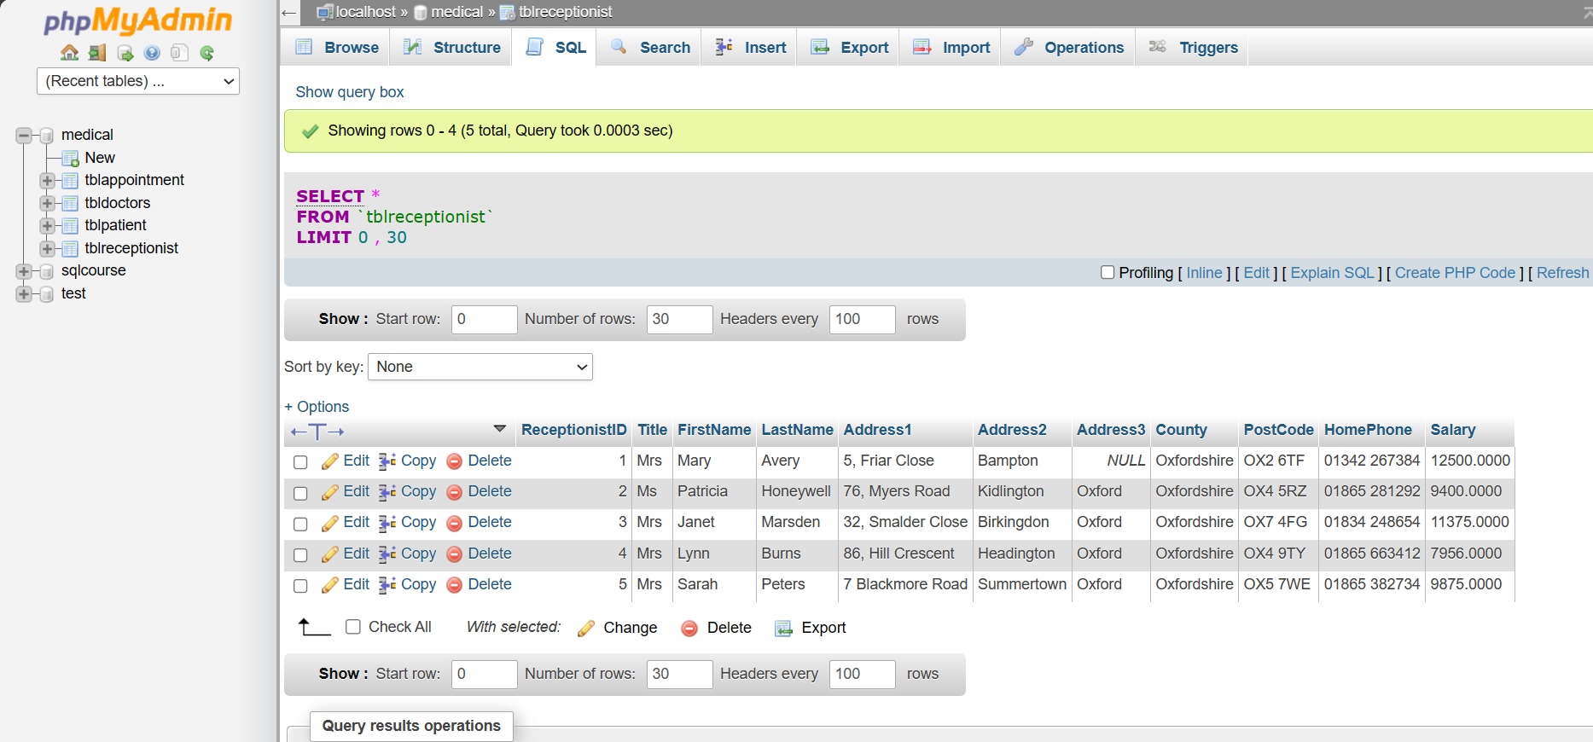

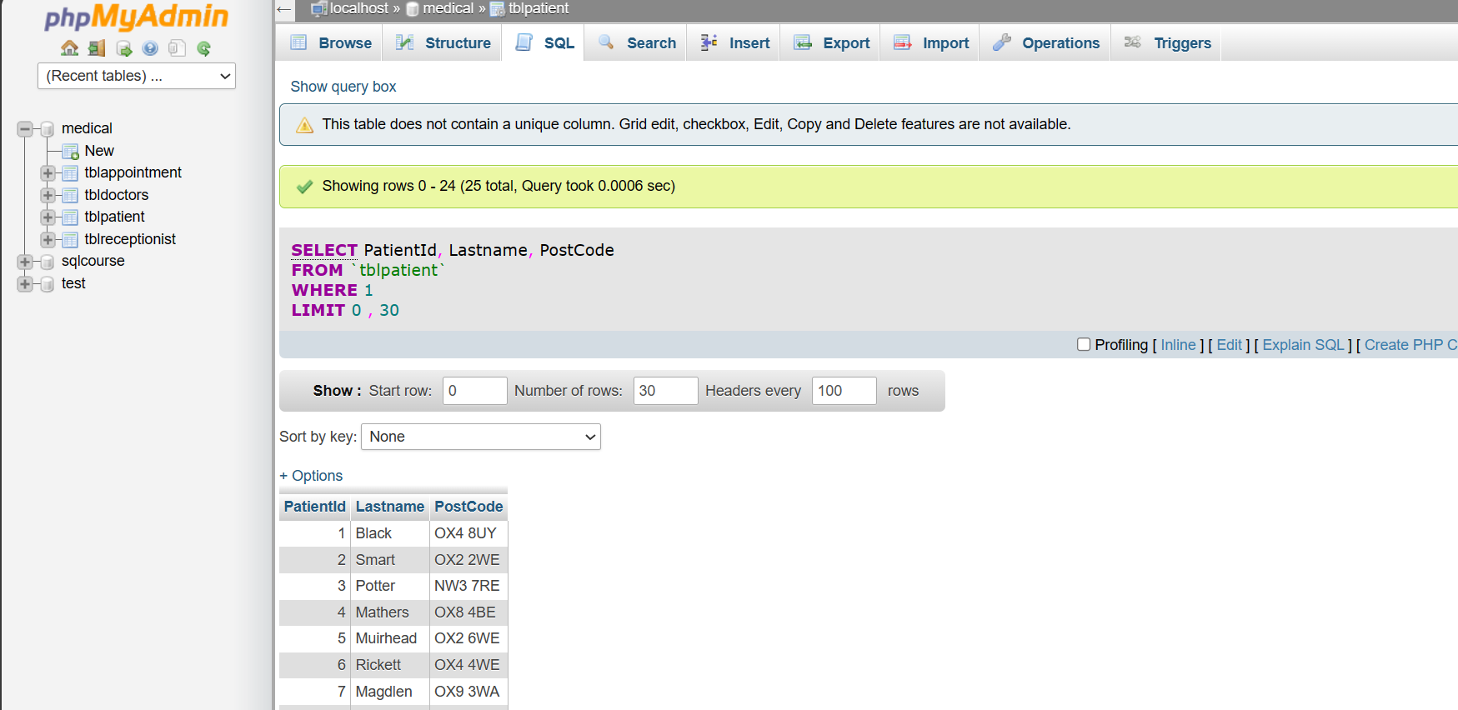

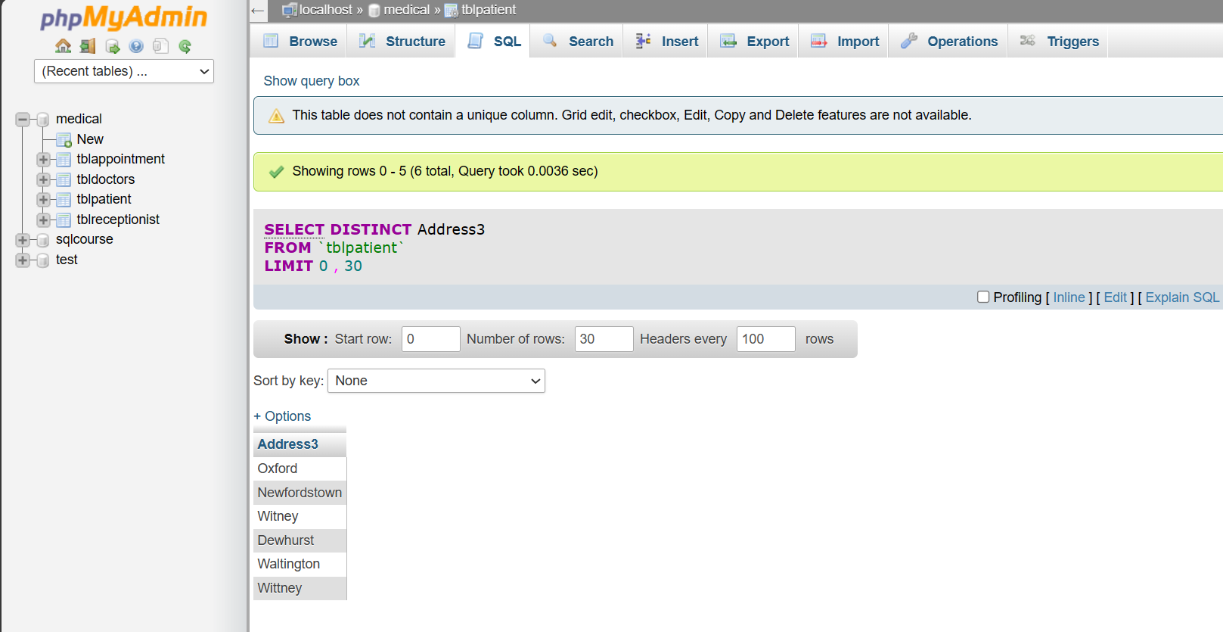

Exercise03: Apply the DISTINCT command to identify the counties that the patients come from using the patients table. This would give an understanding of the geographic spread
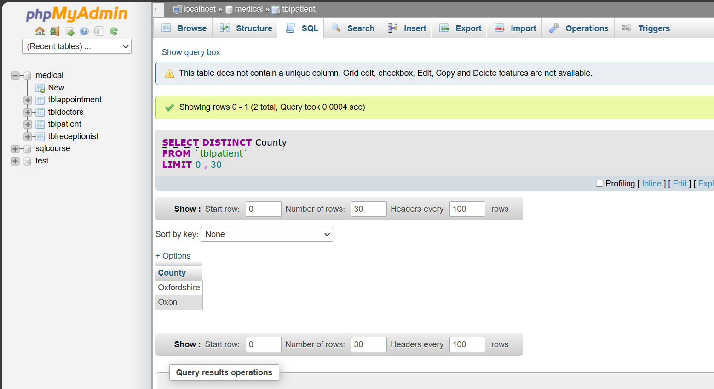
Exercise04: Also apply the DISTINCT on the title attribute, which would suggest to us, what age groups the patients are being drawn from.
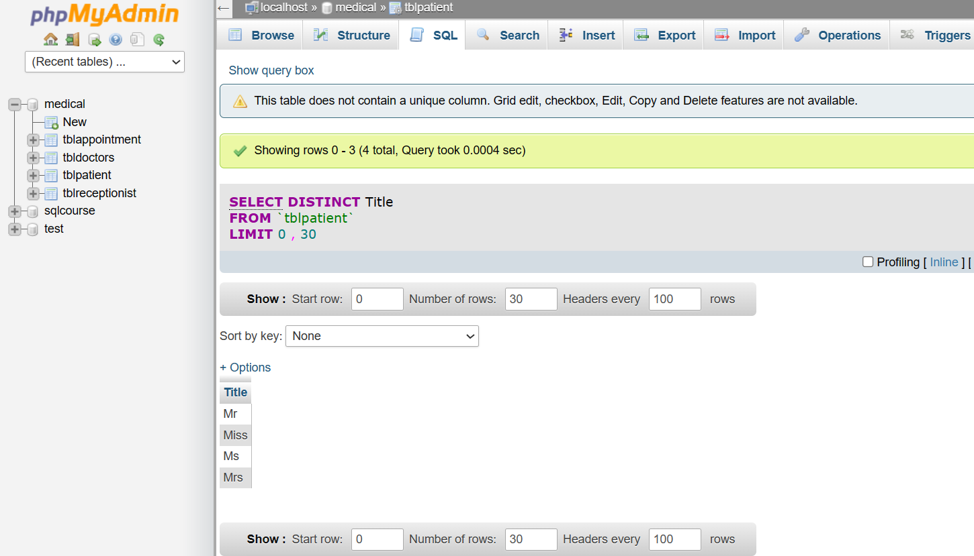

Querying Data and Sorting Data
Exercise01: Using locations select * attributes and display. Then use Select for three attributes including the primary key and display. Make sure to distinguish where the primary key is coming from in terms of the table name.
e.g. tablename. attribute
Selecting a range of attributes from the jobs table
select location_id, city, postal_code
from locations;
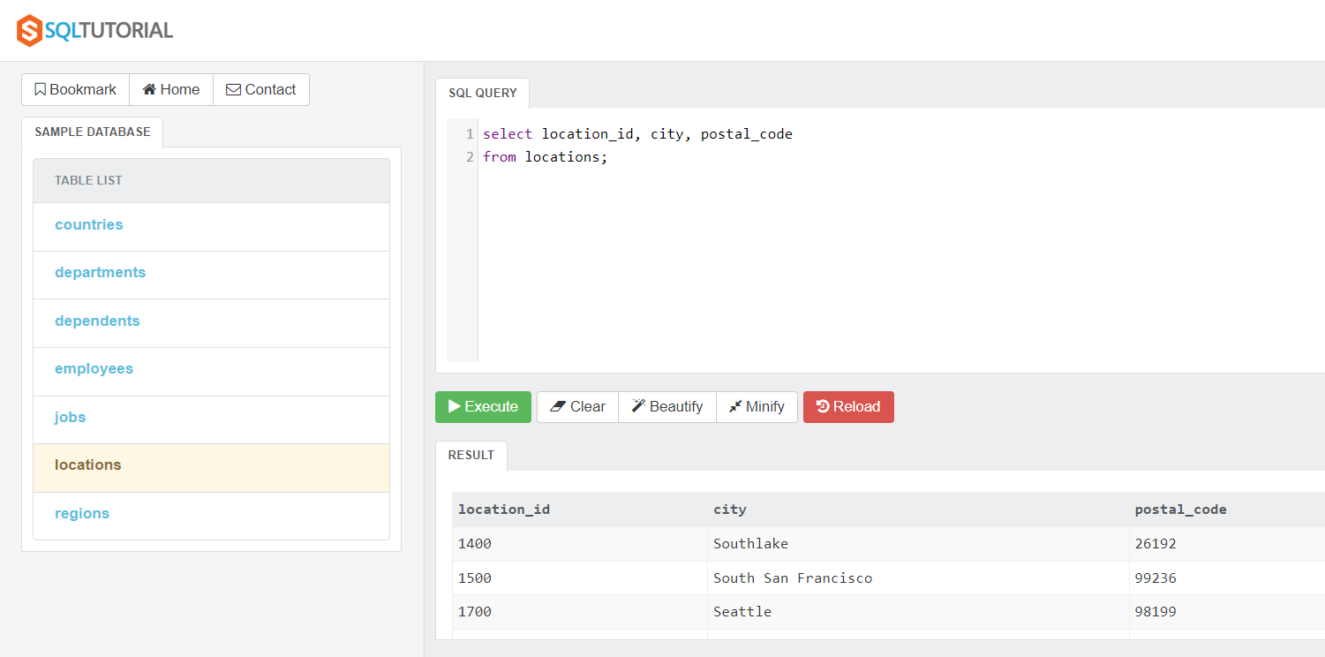
Using an abbreviated table alias and then applying it on the top line of the code
select l.location_id, city, postal_code as 'zip code'
from locations l;
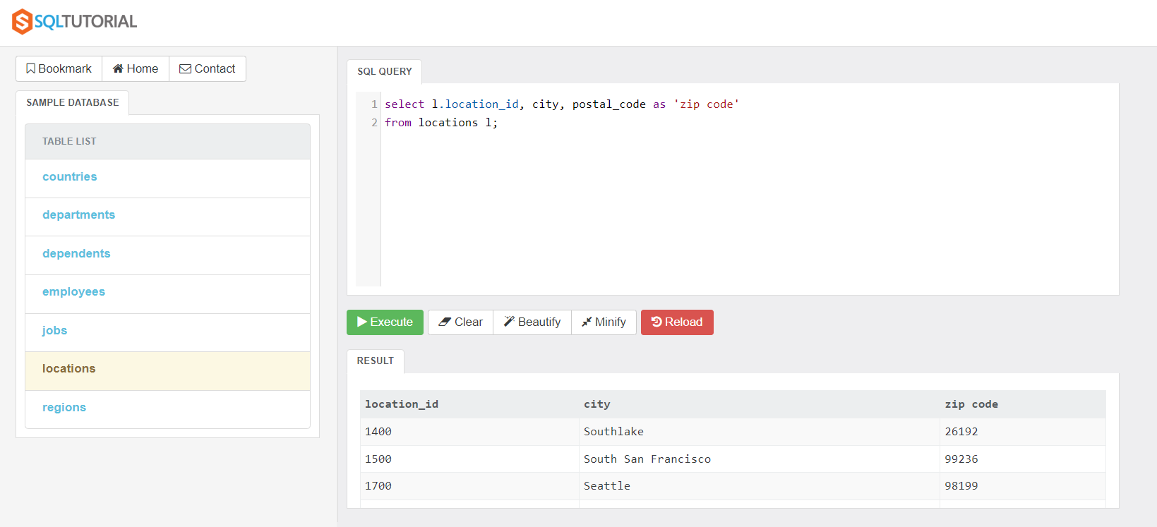

Exercise02: Create an sql – that will show the employee_id, last name and their salary. Then use an alias for the table name – simply use the letter e to reference it. Instead of salary use the alias ‘Monthly Salary’ for the last attribute.
Determine the yearly salary assuming that the salary in the employee table is ‘Monthly salary’
select employee_id, last_name, salary *12 as 'Yearly Salary'
from employees;
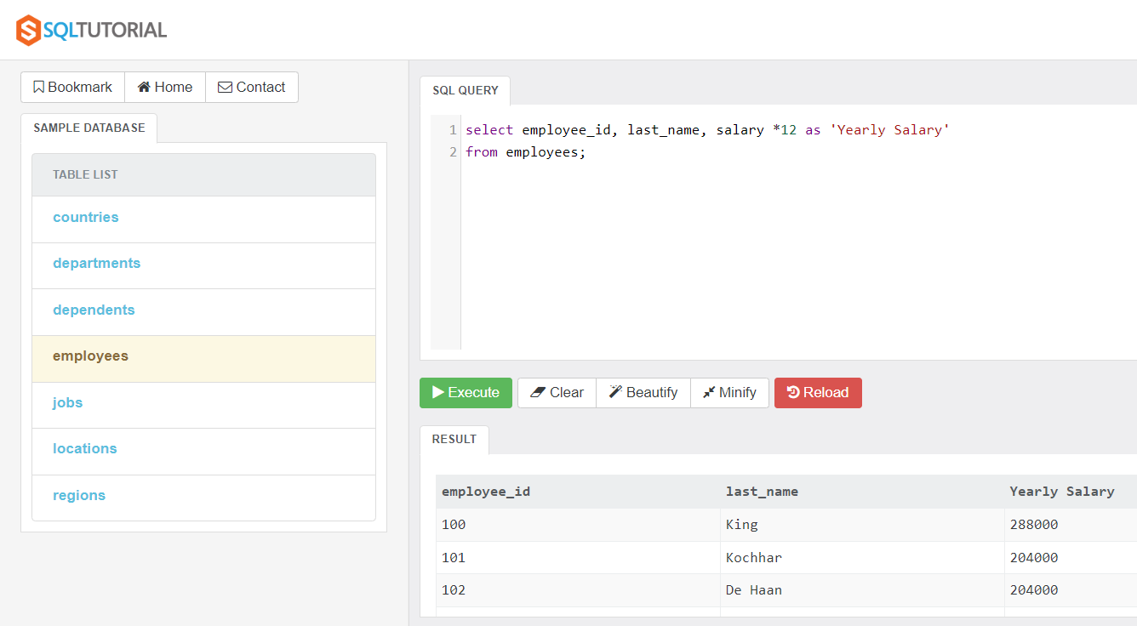
Determine the years of service using the functions (DATEDIFF) and also (ROUND)
select employee_id, last_name, round(DATEDIFF('2021-11-17',hire_date)/365, 0) AS 'Years of Service'
from employees;

Exercise03: On the select clause – combine the persons first name with their name last to be shown as the alias called ‘Fullname’
Use the ORDER BY clause to sort according to one of the attributes
select country_id, country_name, region_id
FROM countries
order by country_name DESC;
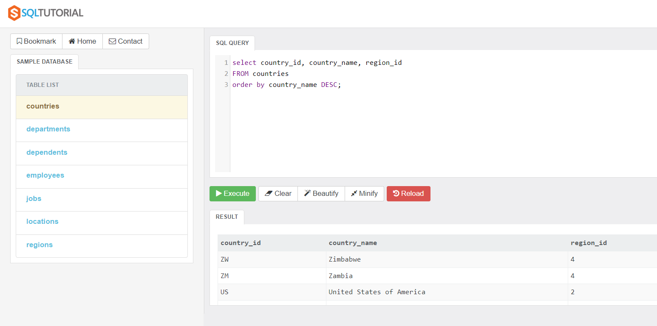

Sort according to two attributes – when not specifically mentioned next to the attributes it means an Ascending sort
SELECT last_name, first_name, phone_number
FROM employees
order by lastname, first_name;
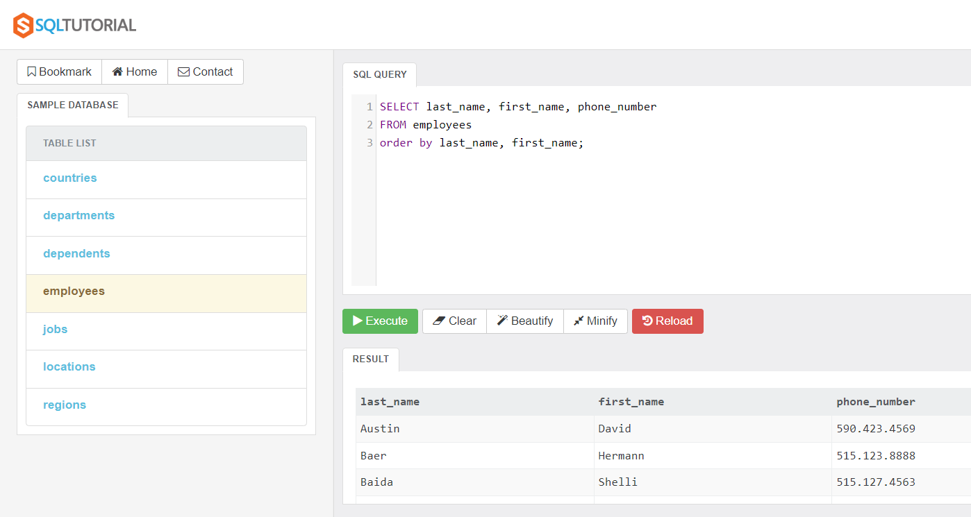

Exercise04: Complete an sql that will display a person’s lastname, email, salary and have the sort done according to the person salary in descending order (so highest will be at the top), if two people have the same salary then the secondary sort should be lastname in ascending order.
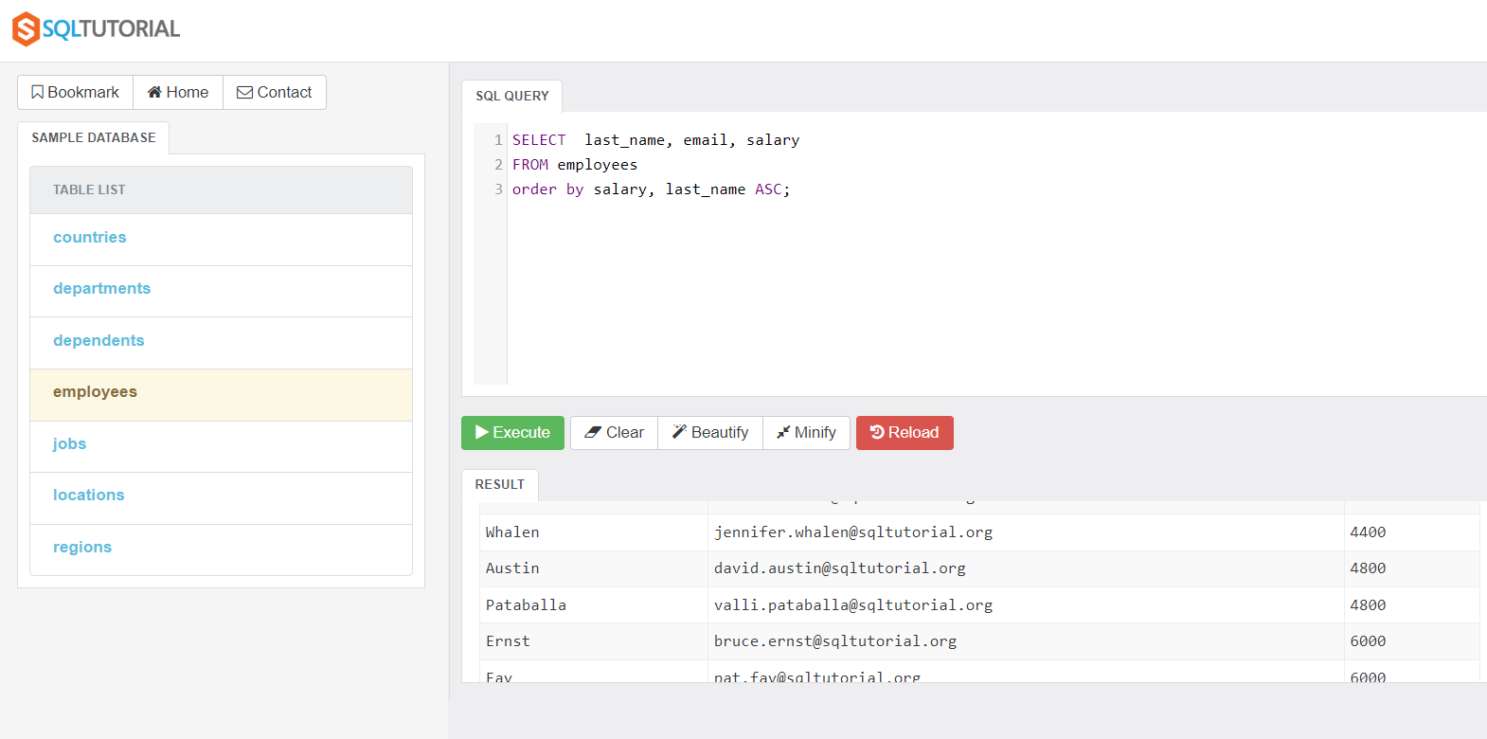

Filtering Data Part01
Exercise 01: Apply the distinct command to determine the individual department ids from the employees table. This should give a straight listing of only the departments id’s without duplication.
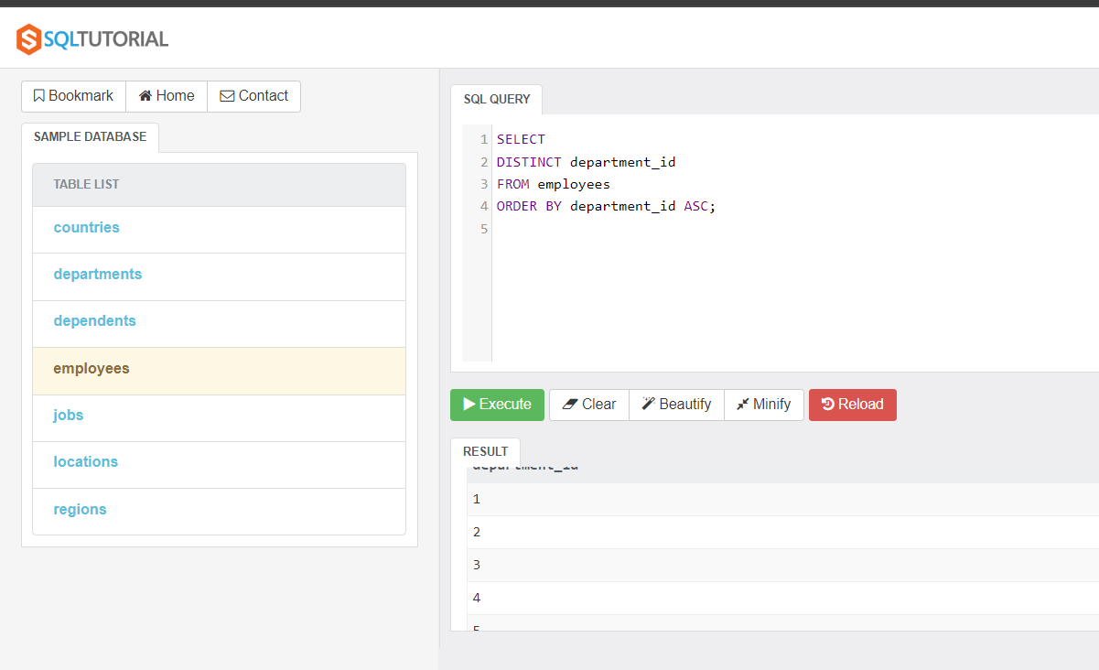
Exercise02: Determine the top salary within the organisation. Using the employees table. Display their employee_id, first name, last name, job_id
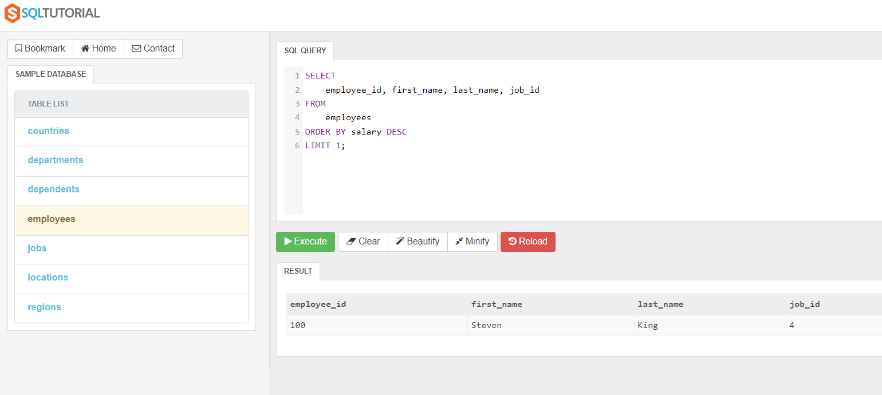
Exercise03: Display a listing of the department names, and department id’s – starting with the 5th department and continuing the 10th department id. Assuming an ascending sort is done on department id.
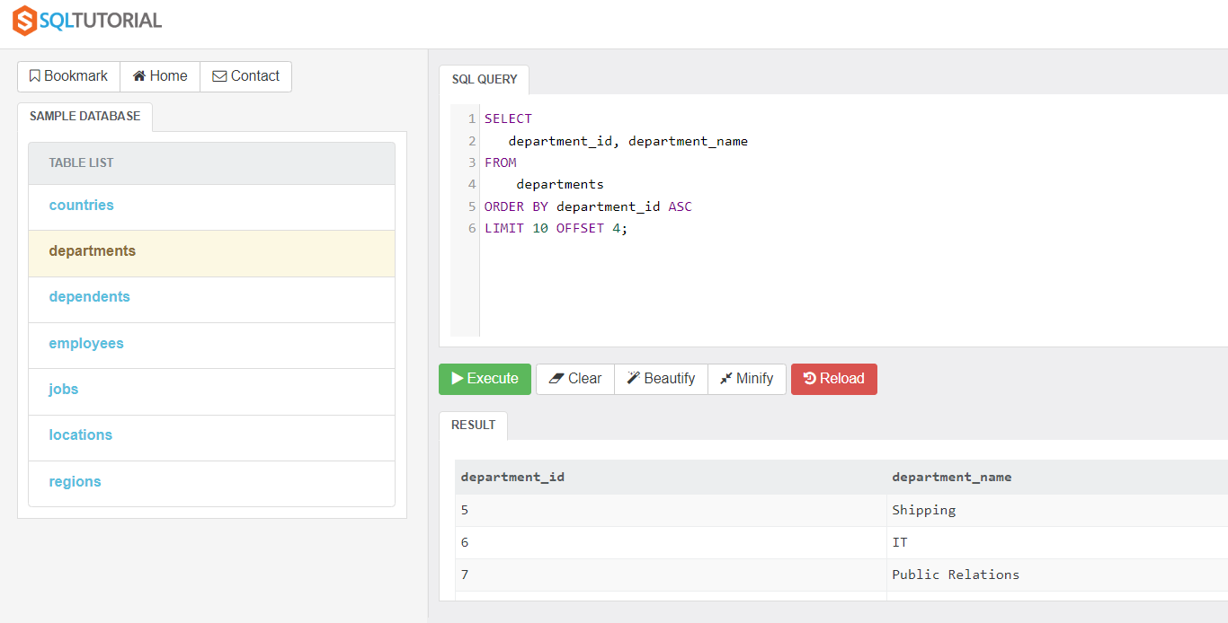

Exercise 04: Complete a distinct command on the location id’s within the department table. To show only a listing of the unique location id’s that the company has.
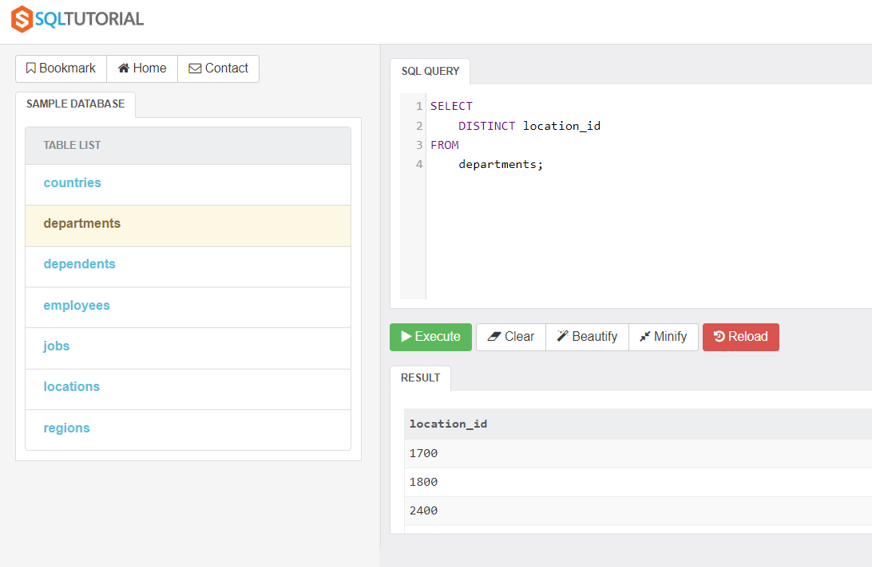
Exercise05: Determine the details – first name, last name, salary, phone number of those employees earning under or equal to 5000.
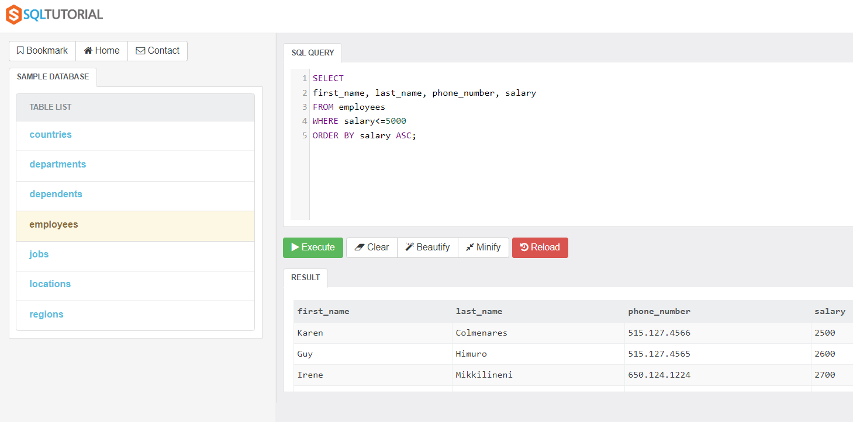
Exercise06: Determine employee_id, first name, last name , hire date to show those people hired after the beginning on 1999.
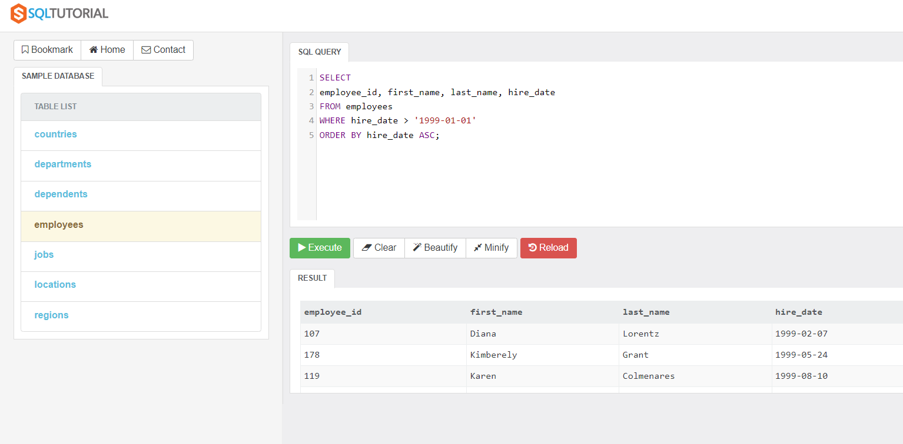

Filtering Data Part02
Exercise01: Write the sql code that will determine anyone whose name begins with ‘P’ and whose salary is below 8000.
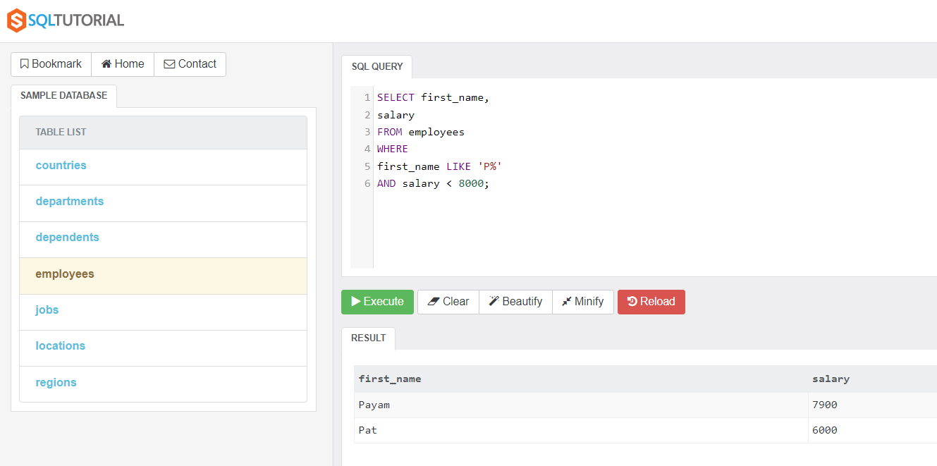
Exercise02: Identify the employees hired in 1997, 1998. They all have a department id of 5.
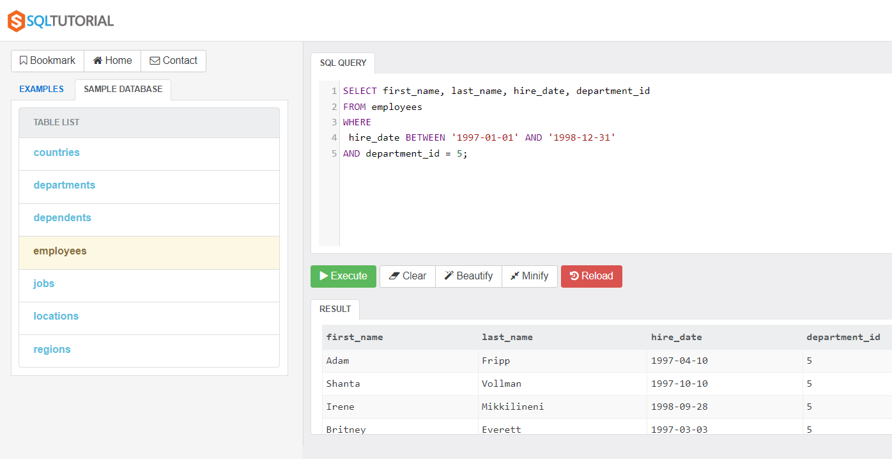

Exercise03: Identify employees that are employed in 1998, 1999, 2000. Display their first name, last name, salary, email, hire_date (alias ‘Year of Hire’) and order by last name in ascending order.
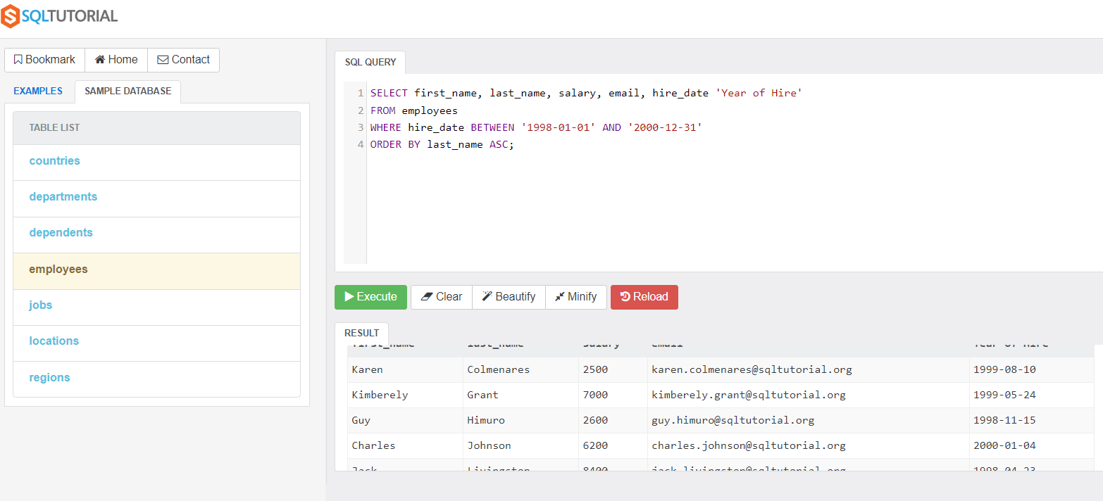
Exercise04: Display all the details of the employees that have a salary that is bounded between 5000 and 10000. (inclusive). Use the inequalities to generate the output within the where statement (>, <, =).
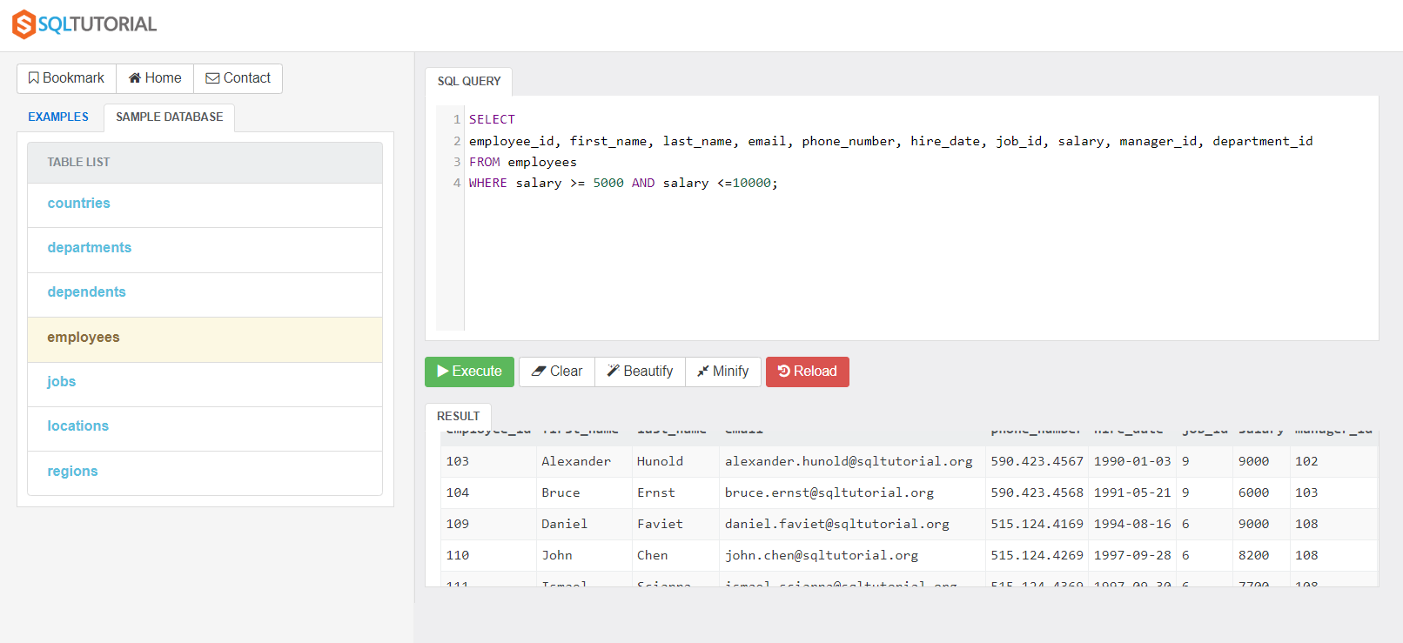

Exercise05: Using the between operator to determine the salary – determine the employees that have salaries between 4000 and 12000. In ascending order according to first name.
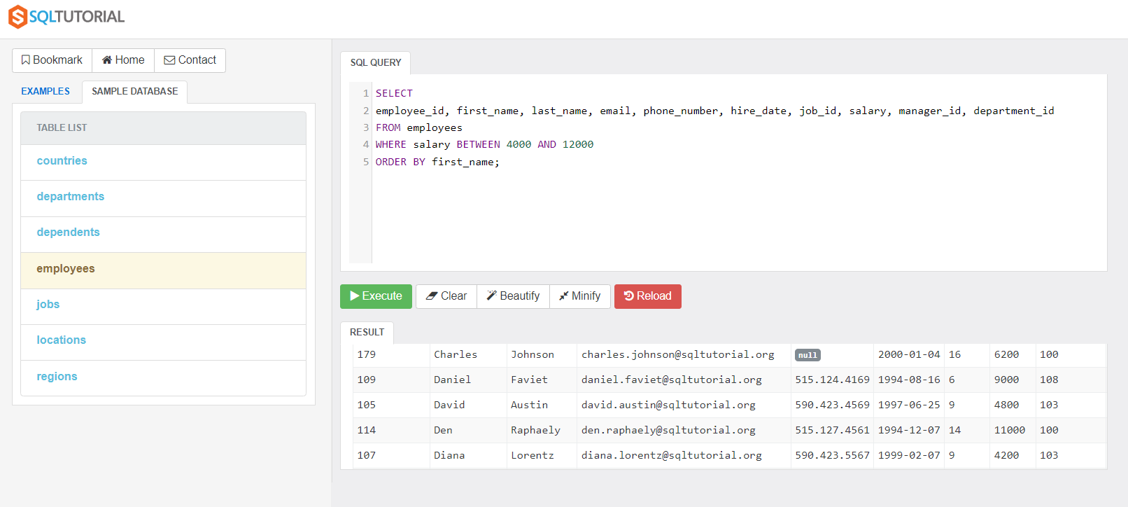
Exercise06: Display all the records for employees that are NOT in the following departments – they are not in 1, 4, 8, 10. So it will display all the others. Do this with a sort according to salary in descending order.
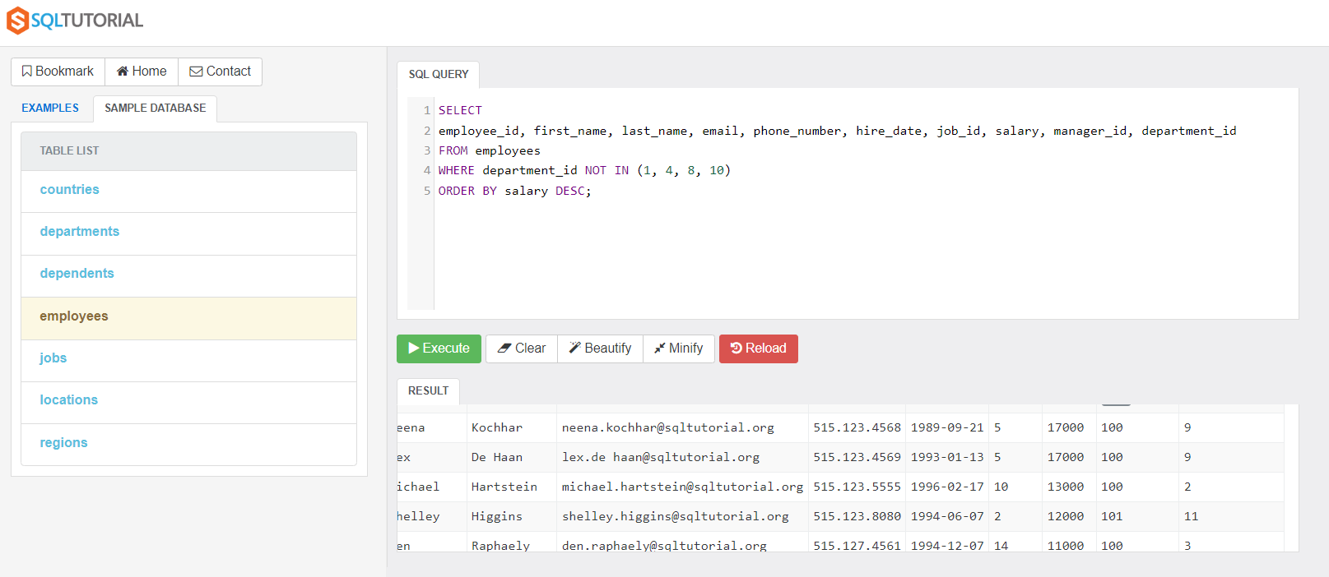
Exercise07: Display the details of the employees that have an ‘s’ at the end of their first name. Sort using ascending sort according to first name
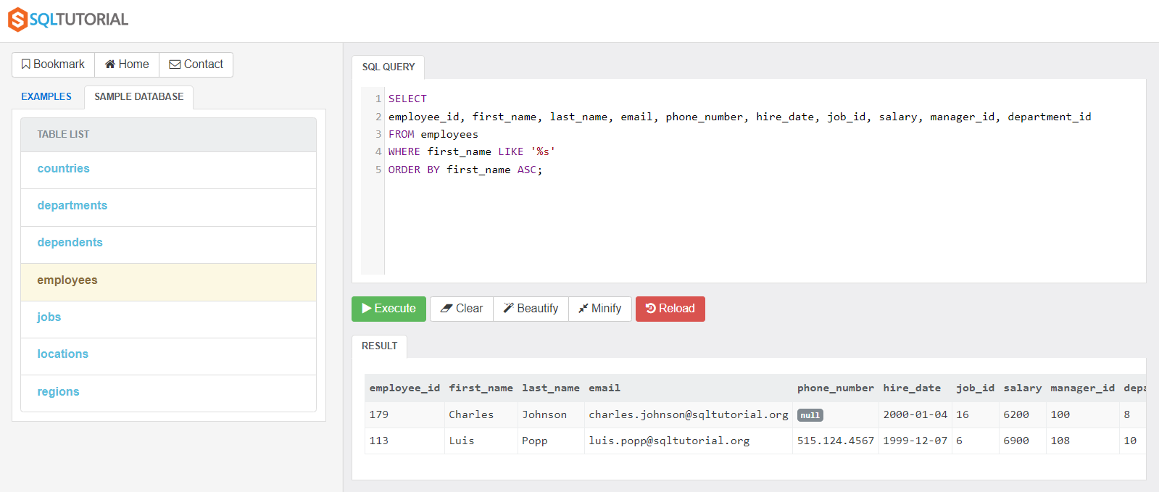
Exercise08: Display the details of employees that have three letters unknown followed by a ‘g’ for their last name.
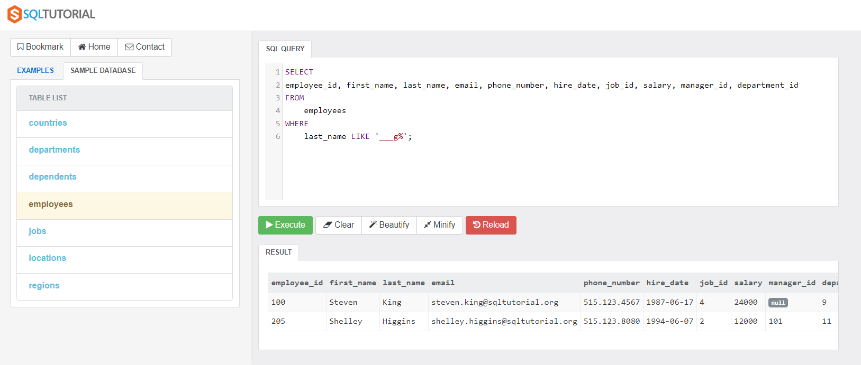

Joins
Study the following diagram – this shows the tables (entities) along with the relationships (i.e. links) that exist between the tables. This is really central to how a relational database operates.
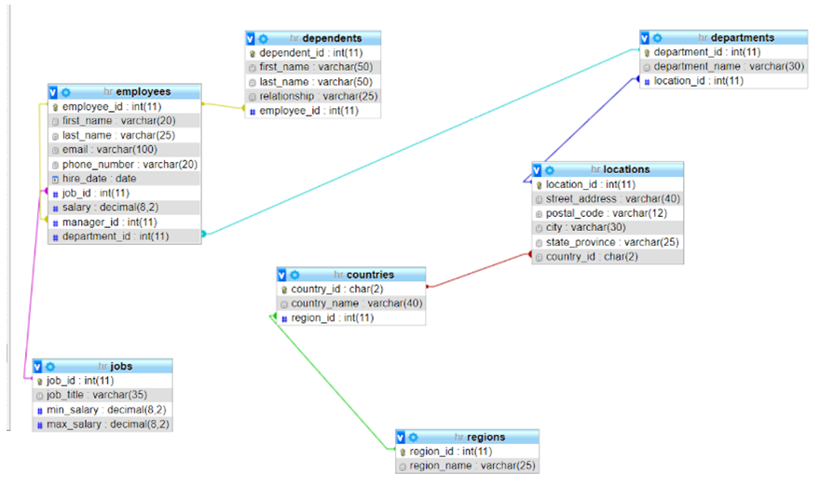
select jobs.job_id, first_name, last_name, job_title, email
from employees inner join jobs on
employees.job_id = jobs.job_id;
Exercise01: Create an sql that will display the following fields (attributes) – first name, last name, manager_id, department_id, location_id. Using an EQUI join display the data with an appropriate query.
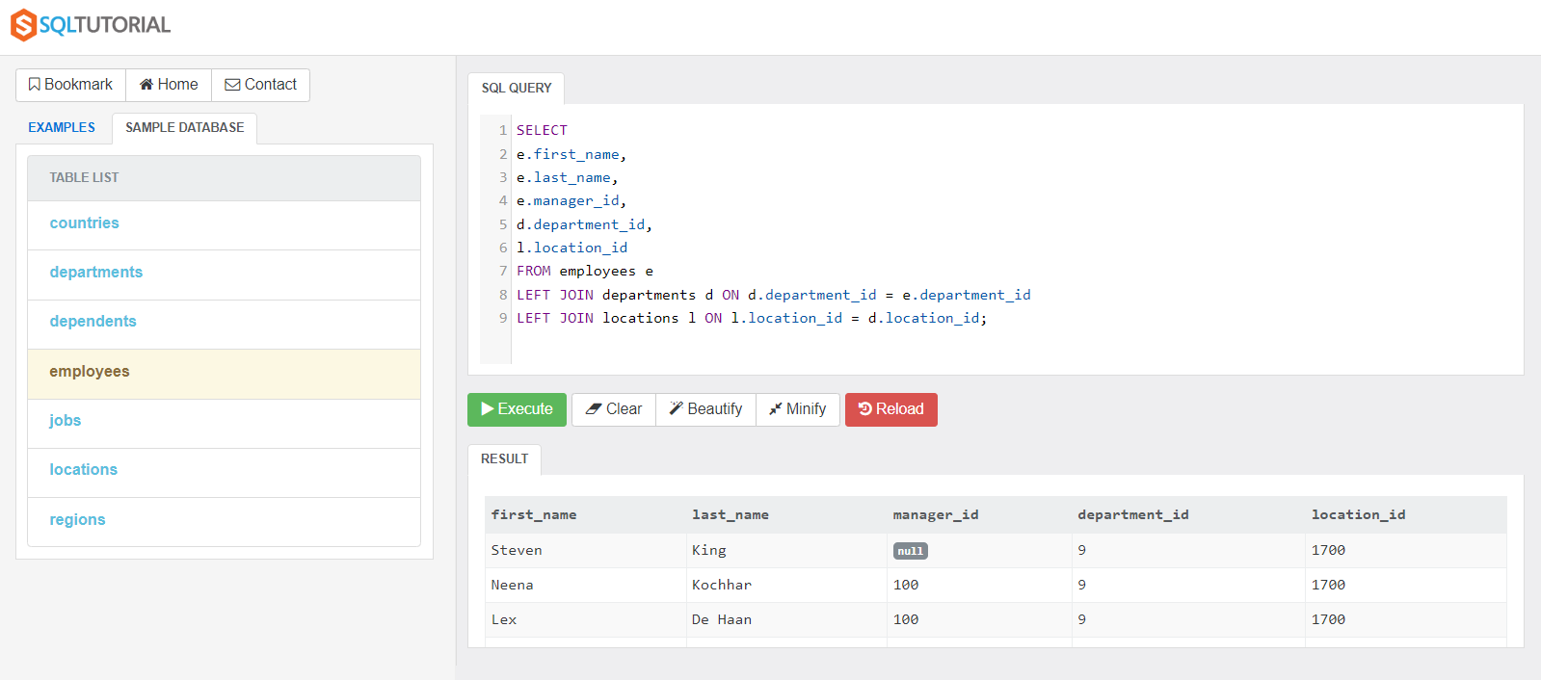
Exercise02: Create an sql that will display the following fields (attributes) – location_id, postal_code, country_id, country_name – apply a series of alias’ to the relevant tables. Then generate the output according to an INNER JOIN. With the primary key ‘location_id’ deciding what will be the prevalent table in the query.
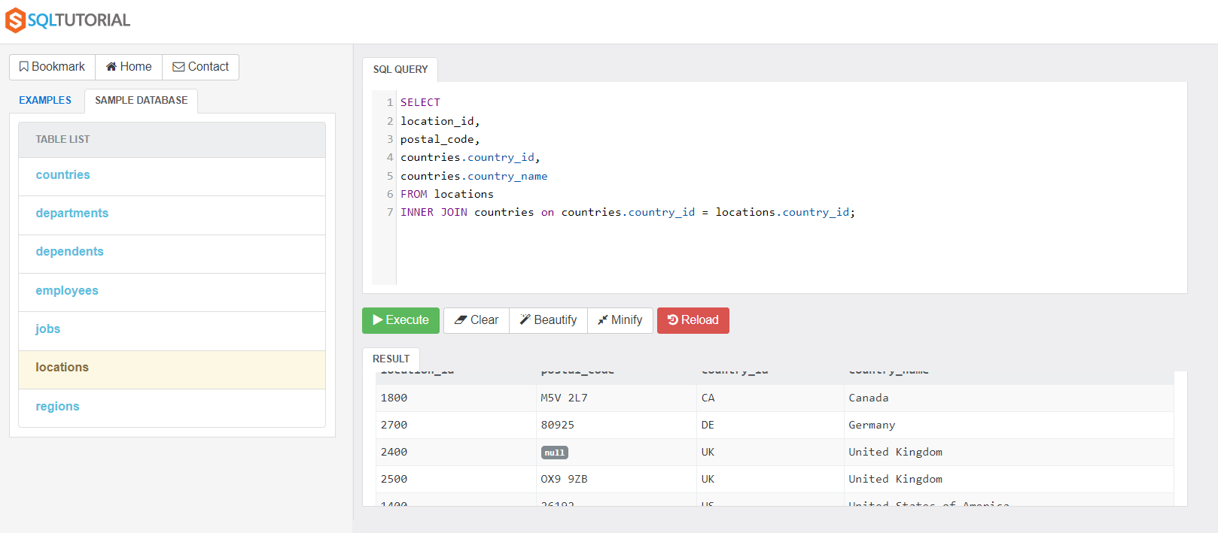
Exercise03: Create a query that will generate the following information, employee_id, first_name, last_name, dependent_id, first_name, last_name, relationship. This will draw information from the employees and dependents tables.
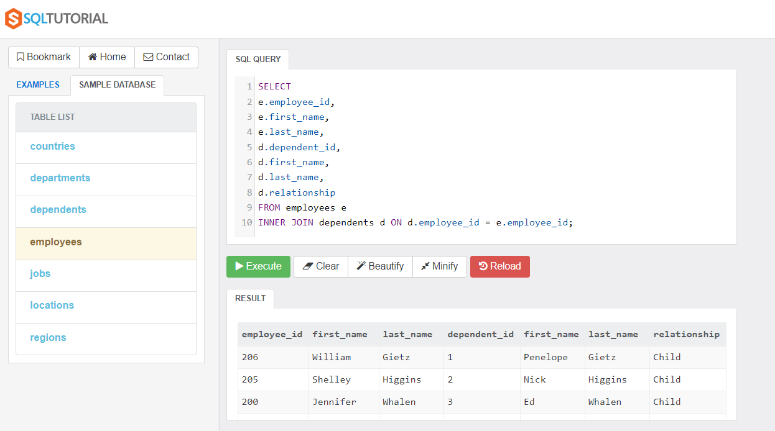

Aggregate Functions
Exercise01: Determine the number of employees in the Sales department. Also create a proper header that shows the information appropriately.
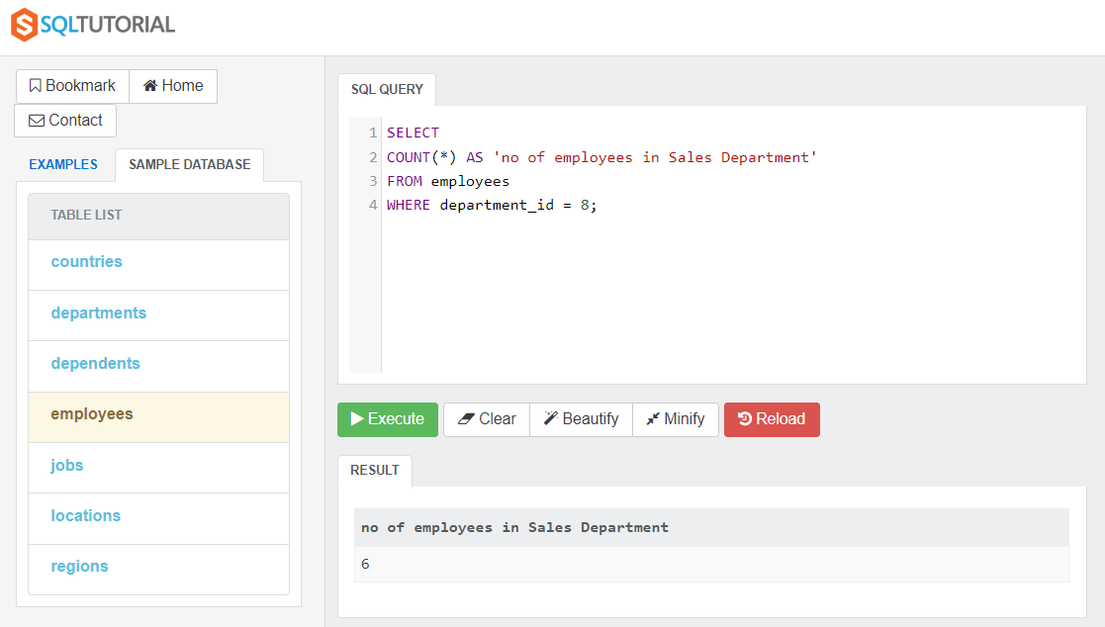
Exercise02: Determine the number of employing working in each of the respective departments.
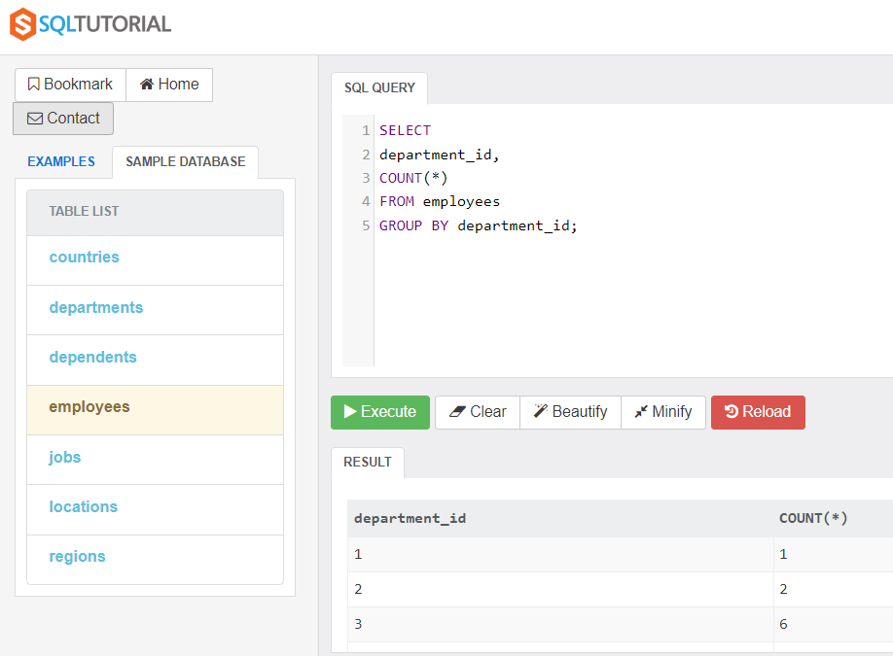
Exercise03: Determine the number of employees each manager will manage from the employees table.
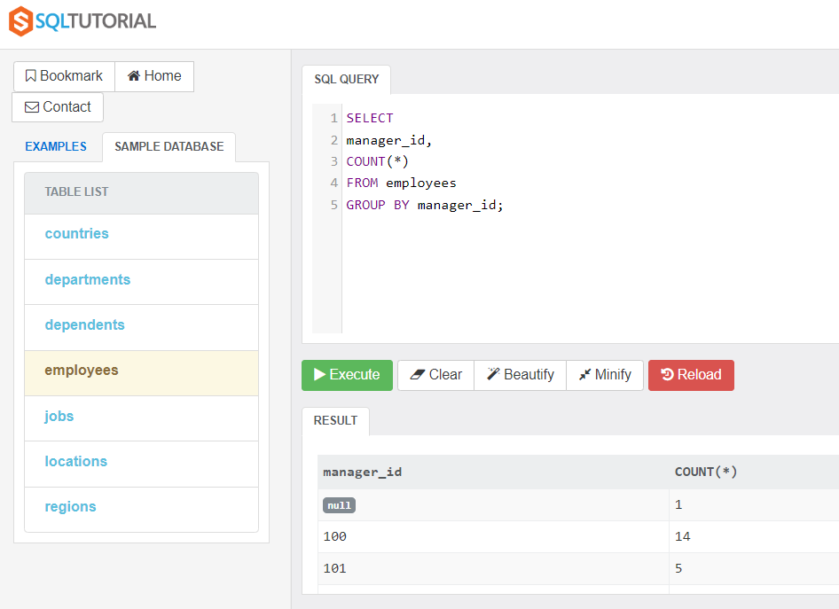
Exercise04: Determine who (if anyone) has two children from the dependents table.
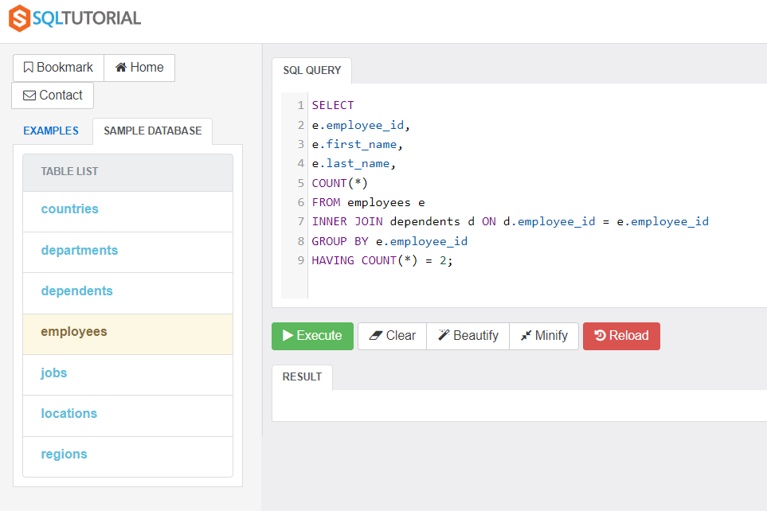
Exercise05: Determine the amount of salary per department. Give a breakdown using only the department_id’s in the output along with the salary amounts.
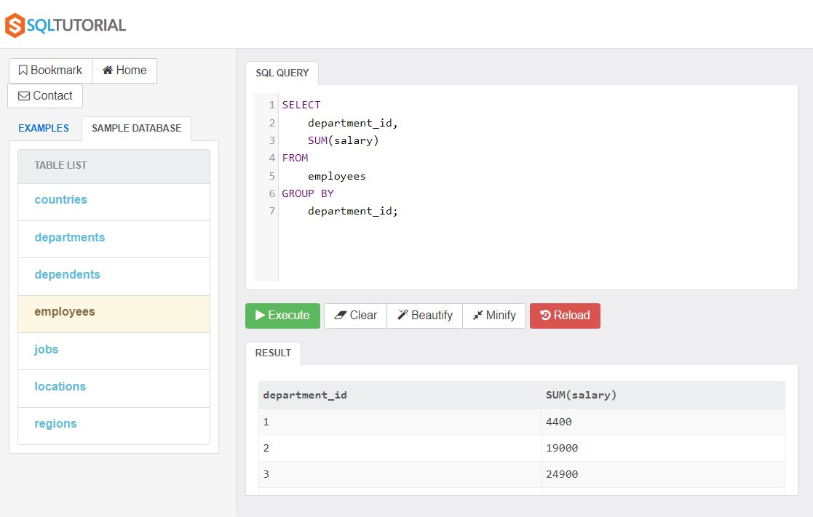
Exercise06: Determine the average of the max salary inside of the jobs table. Round to two decimal places.
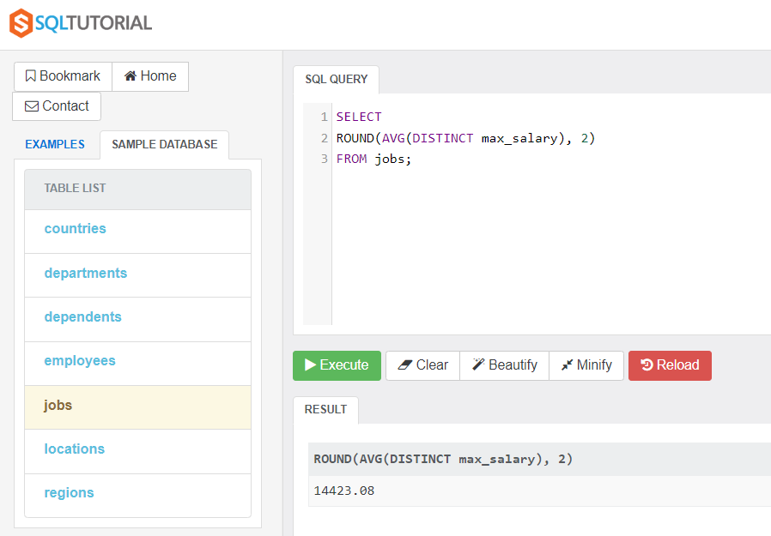

Grouping Data
Exercise01: Create a group by operation on job_id that will show the number of counts that each job_id corresponds to.
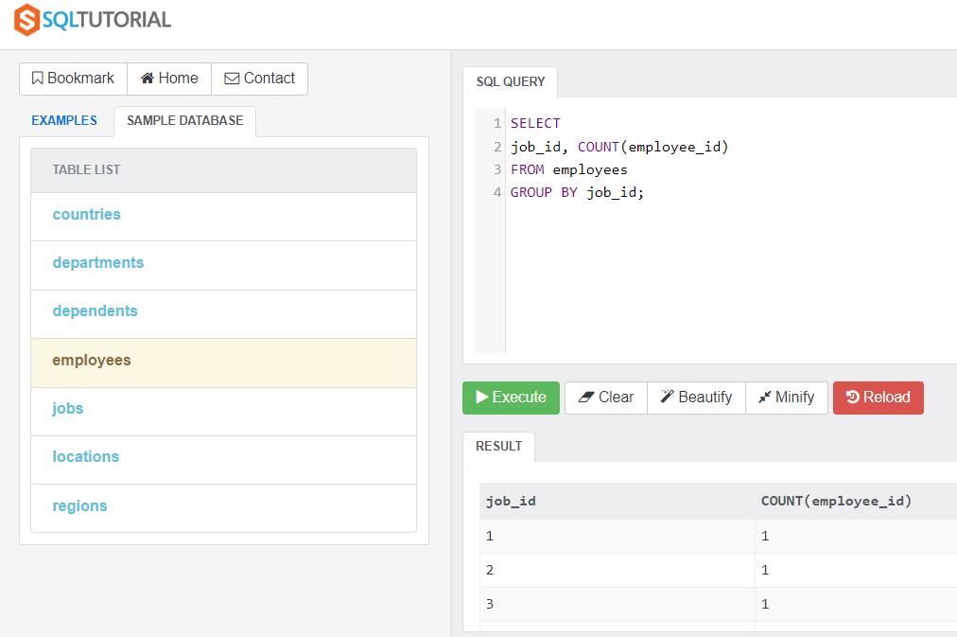
Exercise02: Then do a where operation on the same series, that will display the output from
job_id = 9.
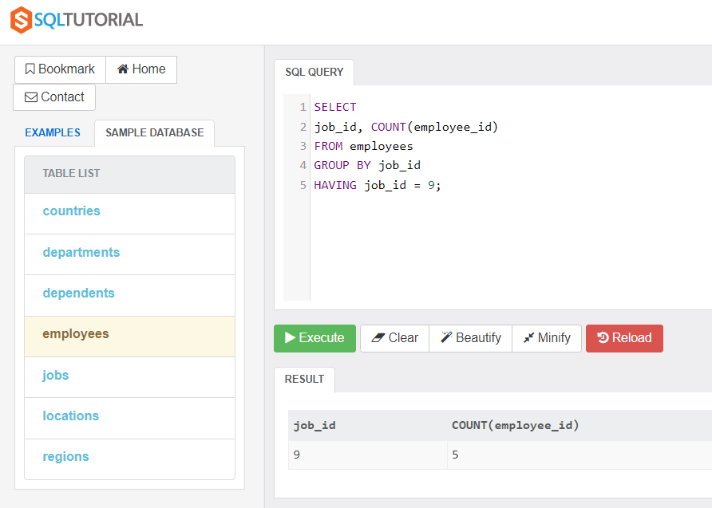
Exercise03: Determine the job titles alongside of the job_ids for the original query.
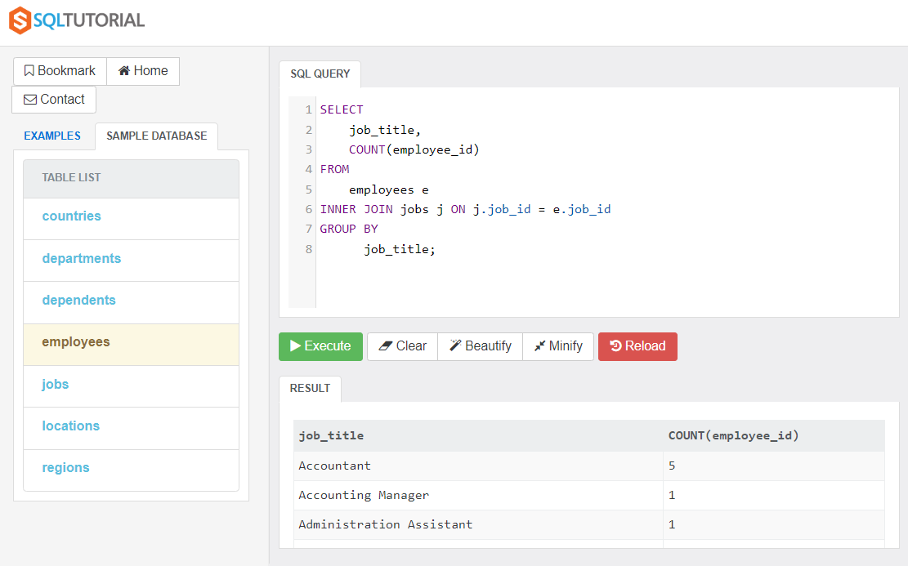

Subquery Part01
Exercise01: Identify the person at the low end of the salary scale – using a subquery to identify the amount they receive. Then use this amount to work out their employee details.
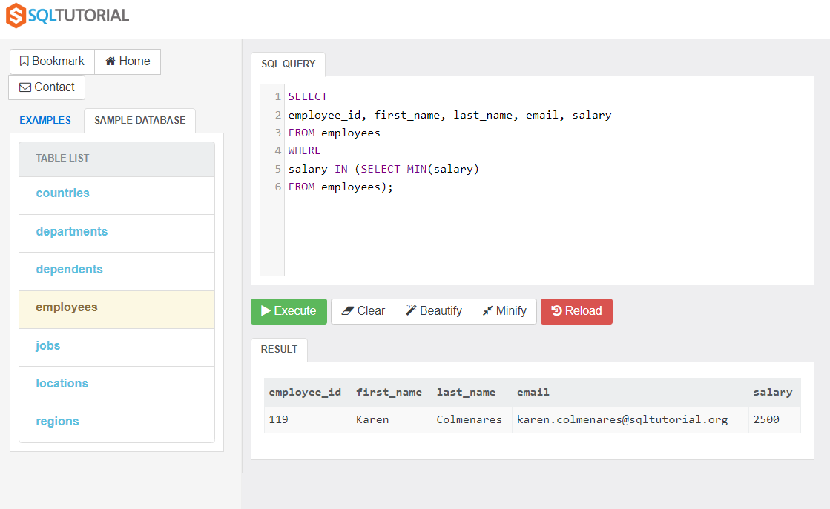
Exercise02: Write the sql code to determine the employees (employee_id, first_name, last_name, salary) for those earning above the average salary.
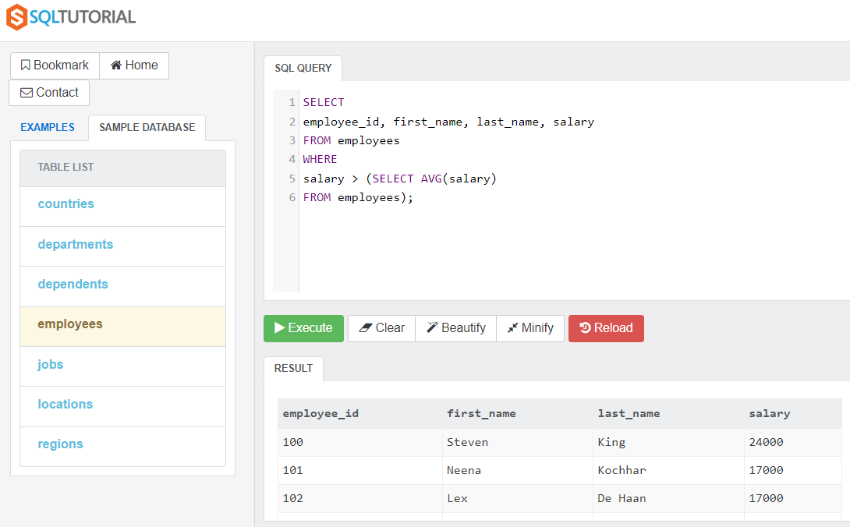
Exercise03: Determine the people earning below the average inside of department_id = 6. Then show their details (employee_id, first_name, last_name, salary, department_id).
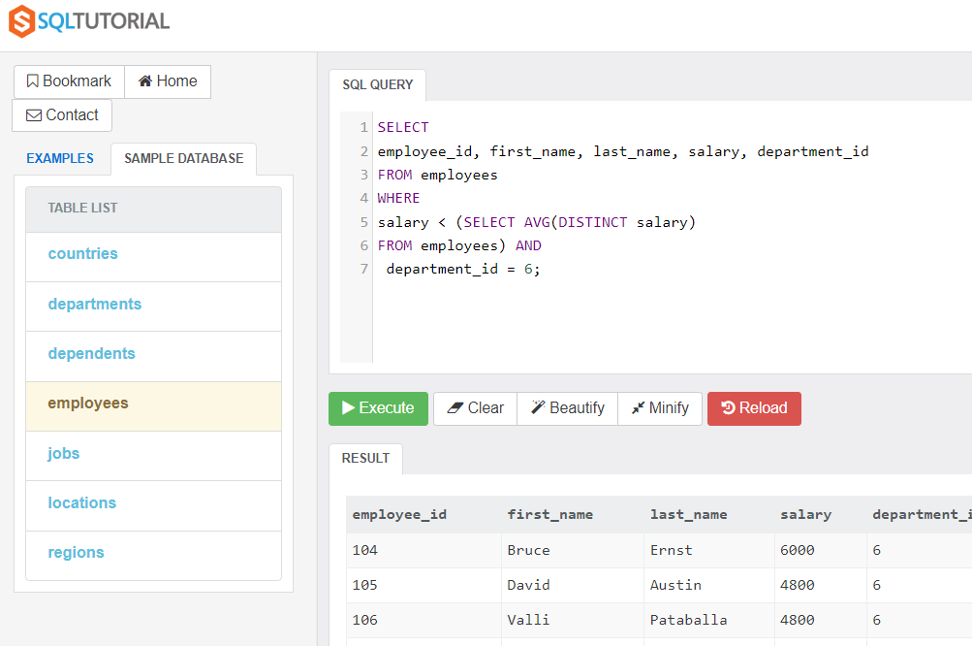
Exercise04: Determine the employees working in the IT department for the company.
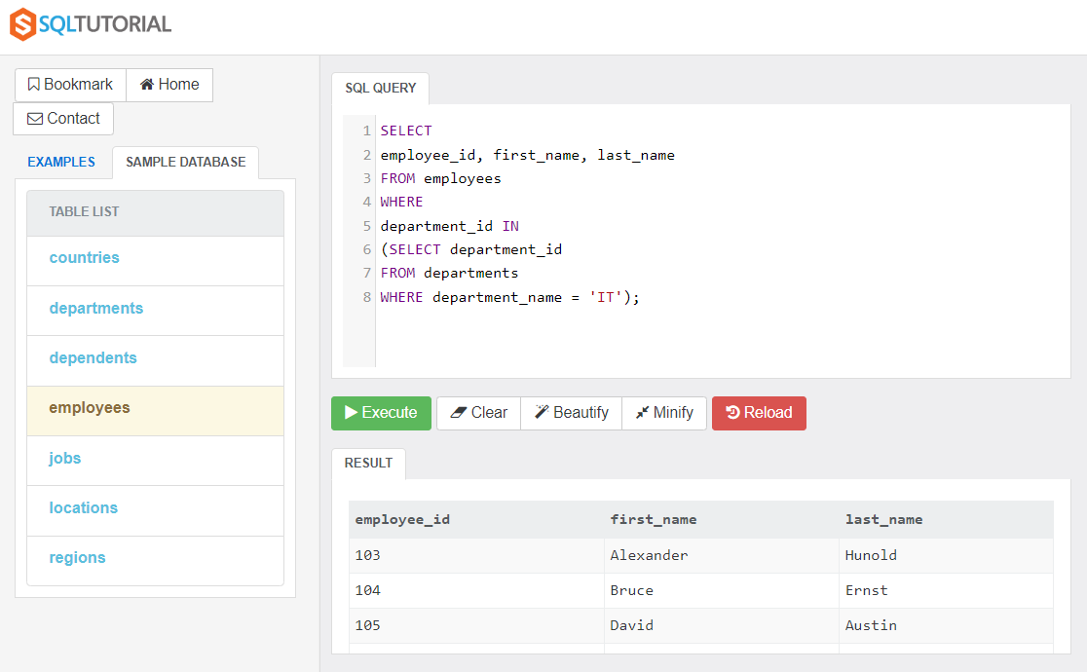
Exercise05: Starting with ‘Jennifer King’ determine the employees name i.e. the father to this child. Who is it?
